Enhancing Road Safety in India: A Data-Driven Approach through Query Processing​

## 

**B.Harsha Vardhan (192224188)**

**S.B Satti Reddy(192224240)**

Guided by

V.Saranya

Junior Research Fellow

Department of Neural Networks

Department of Computer Science and Engineering,

Saveetha School of Engineering, SIMATS Thandalam, Chennai

March – 2024

**PROBLEM STATEMENT**

Creating a well-defined problem statement is crucial for addressing specific challenges effectively. A problem statement outlines the issue at hand, its context, and the impact it has on stakeholders. Below is a structured approach to formulating a problem statement, followed by an example related to population trends and road safety in India.

Structure of a Problem Statement

1. Context: Briefly describe the background or environment in which the problem exists.
2. The Problem: Clearly define the specific issue or challenge.
3. Impact: Explain the consequences of the problem on individuals, communities, or systems.
4. Objectives: State what you aim to achieve by addressing the problem

**INTRODUCTION:-**

Road safety is a pressing concern in India, where the rising number of vehicles and the increasing complexity of urban traffic have led to alarming rates of road accidents and fatalities. According to the Ministry of Road Transport and Highways, India recorded over 150,000 road deaths in 2021 alone, making it one of the countries with the highest road traffic mortality rates in the world. The multifaceted nature of road safety issues—encompassing driver behavior, road conditions, vehicle safety, and enforcement of traffic regulations—demands a comprehensive and systematic approach to effectively address the challenges at hand. This introduction sets the stage for a deeper exploration of how a data-driven approach can transform road safety initiatives in India. By focusing on the collection and analysis of relevant data, the identification of risk factors, and the implementation of evidence-based strategies, this approach aims to create safer road environments,

**Historical and Current Road Safety measures**

The National Road Safety Policy, introduced by the Indian government in 2010, set out a framework for improving road safety. The policy aims to reduce road traffic fatalities by 50% by 2020 (though the target remains unmet) through improved law enforcement, better road infrastructure, and public awareness campaigns. The policy focuses on Improving road engineering and design to prevent accidents. Implementing stricter traffic laws and penalties for violations. Raising awareness on road safety through education and media campaigns. The Road Transport and Safety Bill (2014)  
In an effort to further strengthen road safety governance, the government proposed the Road Transport and Safety Bill in 2014. The bill includes provisions for.Stricter punishment for traffic violations, including fines and imprisonment for offenses like drunk driving, speeding, and driving without a helmet or seatbelt. Establishment of the National Road Safety and Traffic Management Board to oversee road safety initiatives. Enhanced compensation for road accident victims and a more efficient claims process.Although the bill was aimed at comprehensive reform, it has faced delays in its passage and implementation.

**Key Road Safety Trends:**

Current road safety trends emphasize technological advancements, data-driven insights, and a focus on protecting vulnerable road users. Intelligent Transportation Systems (ITS) like vehicle-to-everything (V2X) communication help drivers make safer decisions by providing real-time updates about traffic, road conditions, and potential hazards. Autonomous vehicles and driver-assistance systems are also becoming more prevalent, aiming to reduce human error, the leading cause of accidents. Enhanced data collection from sensors and AI analytics enables city planners to identify high-risk areas and design safer roads. Additionally, there’s a growing emphasis on pedestrian and cyclist safety, with dedicated bike lanes, lower urban speed limits, and improved crosswalks. Campaigns promoting safe driving behavior and the adoption of Vision Zero—a global initiative to eliminate traffic fatalities—are encouraging safer practices on the road, with many cities setting ambitious targets to minimize road injuries and deaths.

**DATASET ANALYSIS:**

**Dataset Collection**

Key datasets for road safety analysis may include:

* **Road Accident Data:** Information on accidents (date, time, location, severity, weather conditions, etc.).
* **Traffic Data:** Vehicle flow, congestion levels, and speed data.
* **Demographic Data:** Population, age, and regional characteristics.
* **Infrastructure Data:** Road types, conditions, signals, and lighting.
* **Weather Data:** Seasonal patterns and their impact on road safety.
* **Enforcement Data:** Details on traffic rule violations and penalties.

**2. Dataset Cleaning and Preprocessing**

* **Handle Missing Values:** Use imputation techniques or drop incomplete records if necessary.
* **Data Normalization:** Scale data for machine learning models.
* **Remove Duplicates:** Identify and drop duplicate records.
* **Categorical Encoding:** Convert categorical data into numerical format using one-hot encoding or label encoding.
* **Feature Engineering:** Create new features like accident density per kilometer, accident severity index, etc.

**3. Exploratory Data Analysis (EDA)**

Analyze trends, patterns, and anomalies:

* **Accident Hotspots:** Use GIS tools or heatmaps to identify areas with high accident frequency.
* **Time-Based Trends:** Analyze accidents by hour, day, and season to detect peak times.
* **Severity Analysis:** Examine factors contributing to fatal accidents.
* **Demographic Impact:** Investigate how age, gender, or occupation influence accident rates.
* **Weather Impact:** Study accident frequency under different weather conditions.

**Visualization Techniques**

* **Bar Charts:** Accident causes, vehicle types involved.
* **Heatmaps:** Geospatial visualization of accident hotspots.
* **Pie Charts:** Distribution of accidents by severity.
* **Line Graphs:** Yearly trend in accidents.

**EXISTING SYSTEM OF APPROACH:**

**Policy Frameworks and Legislation:**

**1.Data Collection and Processing:**

Traditional demographic analysis relies heavily on data collected from censuses, surveys, and administrative records. Agencies such as the United Nations and the World Bank compile and disseminate comprehensive demographic data. However, these datasets can contain inconsistencies, missing values, and outdated information, which can hinder accurate analysis

**2.Statistical Techniques:**

Conventional methods of analyzing population trends include basic statistical techniques such as linear regression, cohort-component methods, and extrapolation of historical trends. These methods often provide a broad overview of population dynamics but can lack precision when projecting longterm trends or accounting for sudden demographic shifts.

**3.Visualization Tools:**

Demographic data is typically presented in static reports, charts, and tables.

While these formats can convey essential information, they often lack interactivity and the ability to drill down into specific trends and patterns. This can make it challenging for stakeholders to fully grasp the implications of the data.

**4. Limitations:**

* Data Quality and Consistency: Handling inconsistencies, missing values,and outdated information can compromise the accuracy of demographic projections.
* Forecasting Precision:Traditional methods may not account for complexinteractions between demographic variables, leading to less accurate long-term projections.
* User Engagement:Static visualizations and reports can be less engaging andharder to interpret, especially for non-expert stakeholders.

**PROPOSED SYSTEM OF APPROACH:**

1. **Data Collection and Processing:**

By leveraging Python,automating the process of data collection from reliable sources such as the United Nations and the World Bank. Python's data manipulation libraries (e.g., Pandas, NumPy) enable efficient handling of large datasets, addressing missing values, and detecting anomalies. This ensures that our data is clean, consistent, and up-to-date, providing a robust foundation for analysis.

1. **Advanced Statistical Techniques:**

Our approach utilizes advanced statistical techniques to improve the accuracy of population projections. Time series analysis allows us to capture trends over time and forecast future values based on historical data. Regression models help identify relationships between demographic variables and predict how changes in one variable influence overall population trends. By combining these techniques, we can develop more precise and reliable population forecasts.

1. **Dynamic Visualization with Matplotlib and Power BI:**

To enhance data visualization, we use Matplotlib, a powerful Python library for creating detailed and customizable plots. These visualizations, including population growth curves, age pyramids, and fertility rate trends, provide a clear and detailed view of demographic patterns. Furthermore, by importing the processed data into Power BI, we create dynamic dashboards that allow users to interact with the data. Power BI's capabilities enable the creation of geographical distribution maps, age and gender demographic breakdowns, and trend lines for population growth across different regions and time periods. This interactive approach makes it easier for stakeholders to explore the data and gain insights.

**Advantages of the Proposed Approach:**

1. **Data Quality and Consistency:**Automated data collection and preprocessing ensure high-quality, consistent, and up-to-date datasets, leading to more accurate analysis.
2. **Forecasting Precision:**Advanced statistical techniques provide more reliable and precise population projections by capturing complex interactions between demographic variables.

**3.User Engagement:**Interactive visualizations and dashboards created with Matplotlib and Power BI enhance user engagement and accessibility, making it easier for stakeholders to explore and understand the data.

**4. Comprehensive Insights:**The integration of Python and Power BI allows for a comprehensive analysis of population trends, enabling users to examine data from various perspectives and uncover underlying patterns.

**ENVIRONMENTAL SETUP:**

1. **Install Python and Necessary Libraries:**
   * Python: Download from  [official website](https://www.python.org/) .
   * Jupyter Notebook: pip install notebook.
2. **Install Required Libraries:** o NumPy: pip install numpy. o Pandas: pip install pandas.
   * Matplotlib: pip install matplotlib. o Seaborn: pip install seaborn. o Geopandas: pip install geopandas (optional).
   * Basemap or Cartopy: pip install basemap cartopy (optional).
3. **Set Up Working Directory:** o Create a directory for project files.
4. **Obtain Population Data:** o Download from sources like United Nations or World Bank.
5. **Create a Jupyter Notebook:**
   * Start server: jupyter notebook. o Import libraries and load data.

**Power BI Environment Setup:**

1. **Install Power BI Desktop:**
   * Download from [official Power BI website](https://powerbi.microsoft.com/desktop/).
2. **Prepare the Data:**
   * Obtain data in CSV or Excel format from reliable sources.
3. **Import Data into Power BI:**
   * Use “Get Data” feature to import population data.
   * Clean and transform data using Power Query Editor.
4. **Create Visualizations:**
   * Use drag-and-drop interface for charts, graphs, and maps.
   * Utilize built-in mapping tools for geographic visualization.
5. **Publish and Share Dashboards:**
   * Publish reports to Power BI service for sharing and collaboration.

**DATA FLOW DIAGRAM:**

**ARCHITECTURE DIAGRAM:**

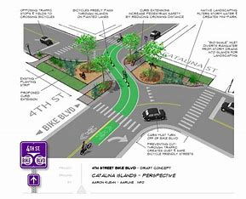

**CODE:**

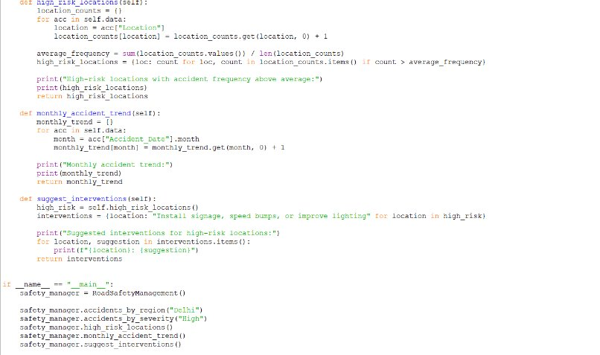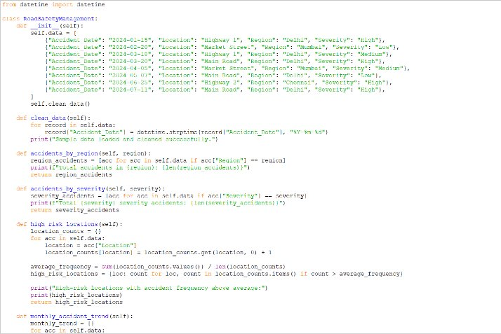

**OUTPUT:**

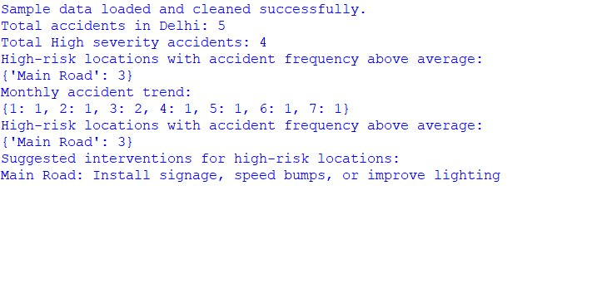 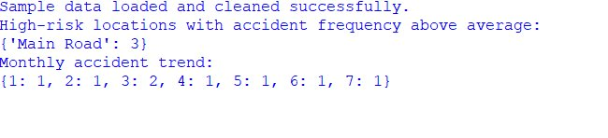

**FIGURE 1:HISTOGRAM PLOT FOR POPULATION GROWTH RATE DISTRIBUTION**

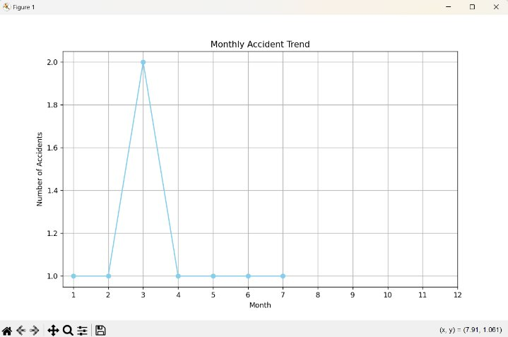

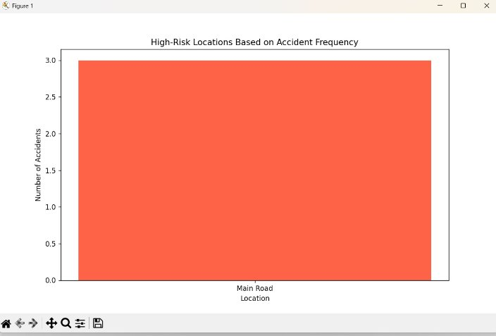

**ANALYSIS:**

**Matplotlib Strengths:**

* **Customization:** Matplotlib provides detailed control over plot aesthetics and layout, allowing for highly customized and specific visualizations.
* **Variety of Plot Types:** Supports a wide range of plot types (bar charts, histograms, scatter plots, etc.), suitable for various kinds of data analysis.
* **Integration with Python:** Seamlessly integrates with Python, allowing for complex data manipulation and analysis using libraries like Pandas and NumPy.
* **Annotations and Styling:** Offers extensive options for adding annotations, customizing colors, fonts, line styles, and more.
* **Export Options:** High-quality static plots can be exported in multiple formats, suitable for publications and reports.

**Limitations:**

* **Interactivity:** Limited interactivity compared to modern dashboard tools; requires additional libraries or frameworks for interactive features.
* **Learning Curve:** Requires knowledge of Python and Matplotlib, which may be challenging for users without programming experience.
* **Real-Time Updates:** Does not natively support real-time data updates; requires additional coding and integration for live data feeds.
* **Collaboration:** Less straightforward for sharing and collaboration compared to web-based dashboard tools. **Power BI Dashboard Strengths:**
* **User-Friendly Interface:** Intuitive and easy-to-use interface, suitable for users with varying levels of technical expertise.
* **Interactivity:** Highly interactive dashboards with features like drill-down, filtering, and dynamic data exploration.
* **Real-Time Data:** Supports real-time data connections, ensuring that the dashboard always displays the most current information.
* **Data Integration:** Can integrate data from various sources, including databases, cloud services, and Excel files.
* **Collaboration and Sharing:** Dashboards can be easily shared with stakeholders and integrated into collaborative platforms like Microsoft Teams.
* **Geospatial Analysis:** Built-in mapping capabilities allow for straightforward geospatial visualizations of population data.

**CONCLUSION:**

Analysing world population trends is a complex and essential task that requires robust data analysis and intuitive visualization. By leveraging Python and Power BI, which can accurately forecast population growth and demographic changes, providing valuable insights for policymakers, researchers, and stakeholders. This study not only enhances our understanding of population dynamics but also offers practical tools for addressing the challenges and opportunities presented by demographic changes. Through comprehensive data analysis and dynamic visualizations, this seems to contribute the informed decision-making and sustainable development in a rapidly changing world. Power BI dashboards play a crucial role in this approach by transforming raw data into interactive, visually appealing insights. These dashboards allow users to explore data through various lenses, including geographical distribution maps, age and gender demographic breakdowns, and trend lines for population growth across different regions and time periods. Power BI’s dynamic capabilities enable users to drill down into specific data points, filter information based on different criteria, and visualize complex data relationships effortlessly. This interactivity makes the analysis more engaging and easier to comprehend, facilitating better communication of findings and fostering datadriven decision-making. By integrating Python’s analytical power with Power BI’s visualization prowess, our approach ensures that stakeholders have access to accurate forecasts and an intuitive platform to explore and understand future population trends, ultimately aiding in the development of effective policies and sustainable urban planning.

Matplotlib is ideal for users who need highly customized visualizations, have complex data manipulation requirements, and prefer using Python for their analysis. It is best suited for static reports and publications where detailed control over plot aesthetics is crucial.Power BI is better suited for users who need interactive, real-time dashboards, want to integrate data from multiple sources easily, and require collaboration and sharing capabilities. It is ideal for business environments where quick insights and userfriendly interfaces are essential.